**Cricket League Management System.**

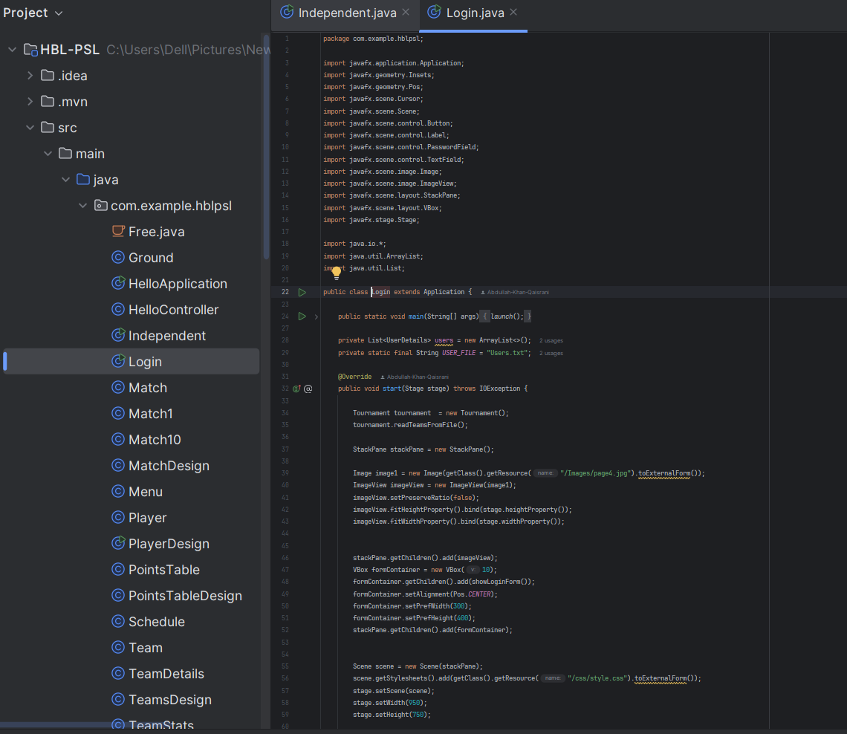

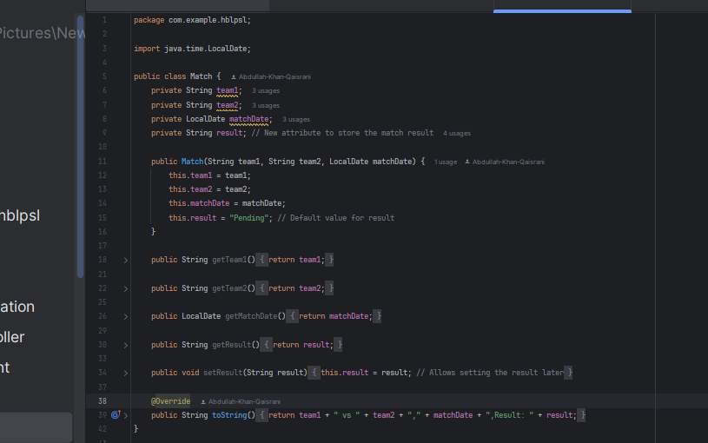

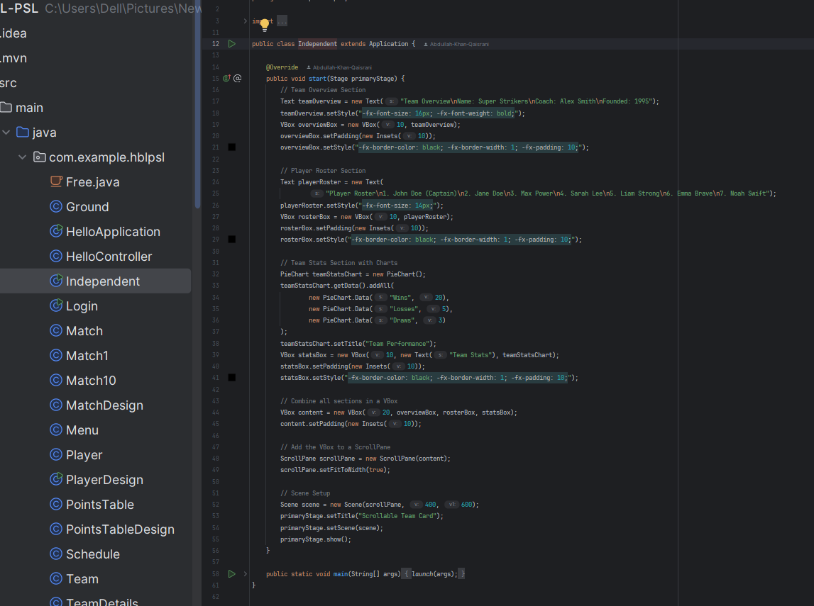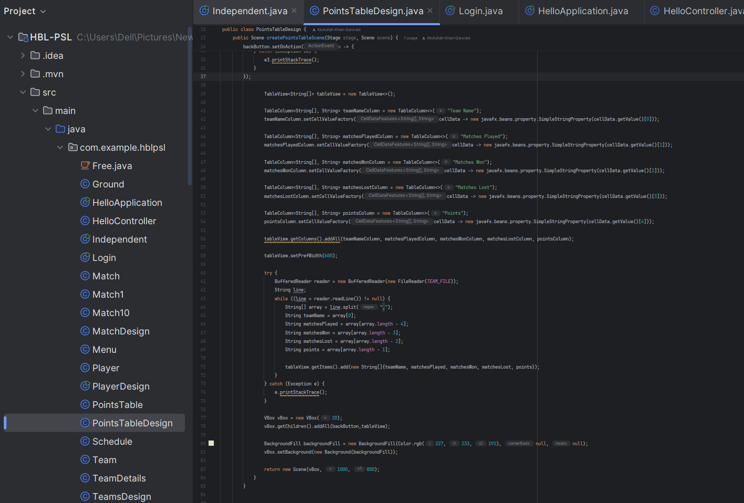

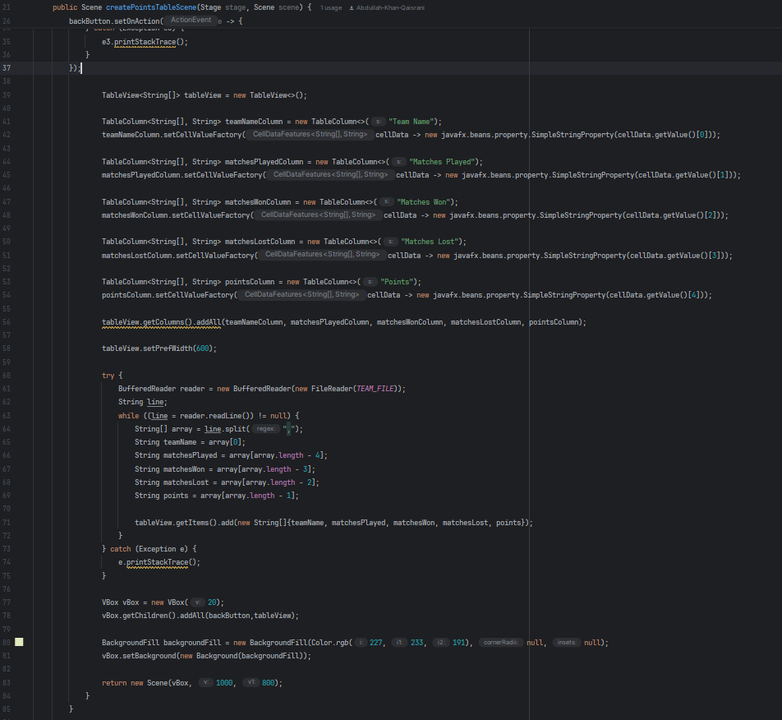

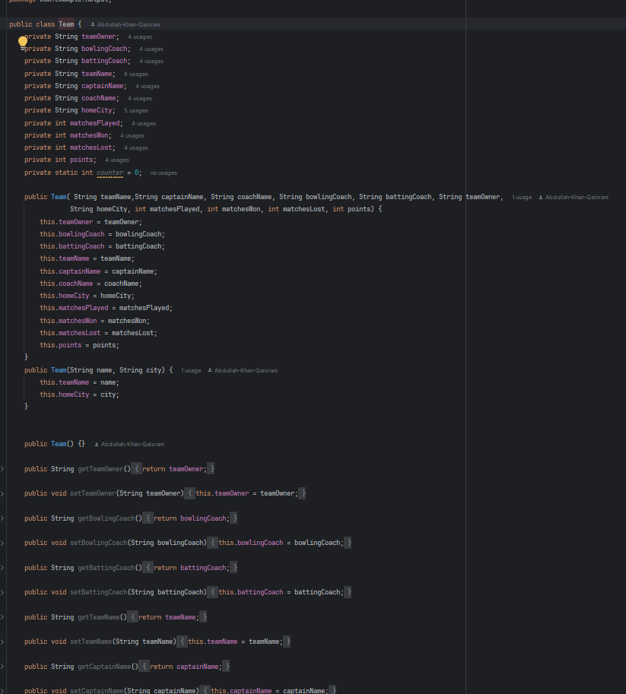

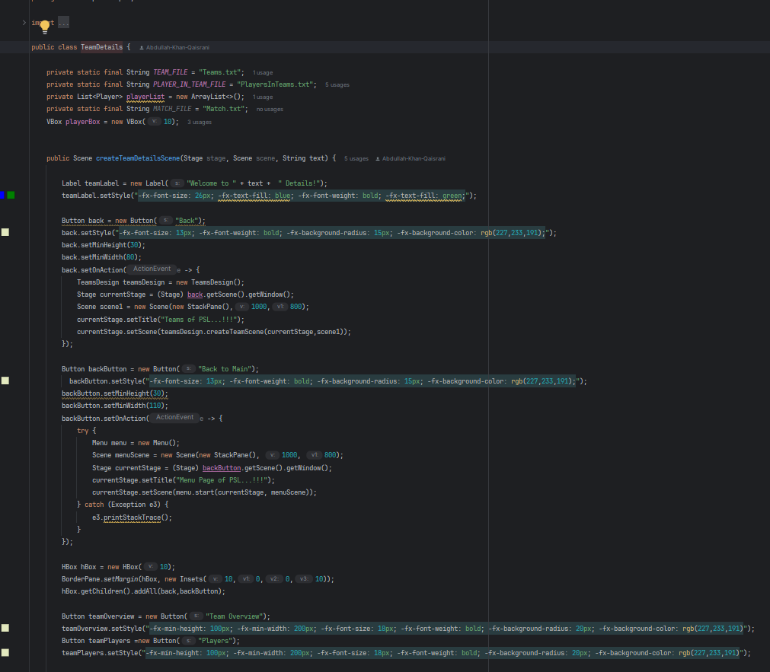



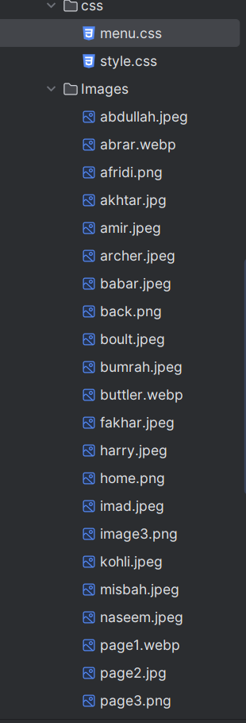

there is a cricket league management system first of all login page appears when we run the Logan class on login page we have to put the username and password if correct username is applied it will change the window and main Menu will appear.

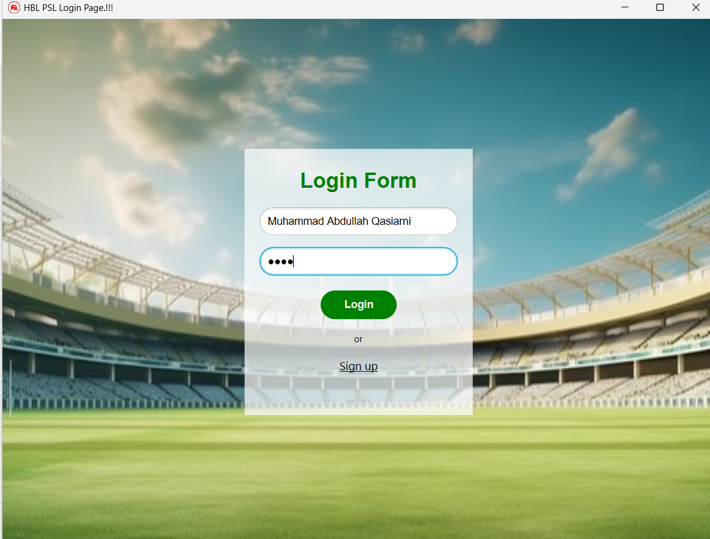

click on sign up if you don't have account the sign of will require username password and confirm password. If there is already an account on specific username it will not proceed

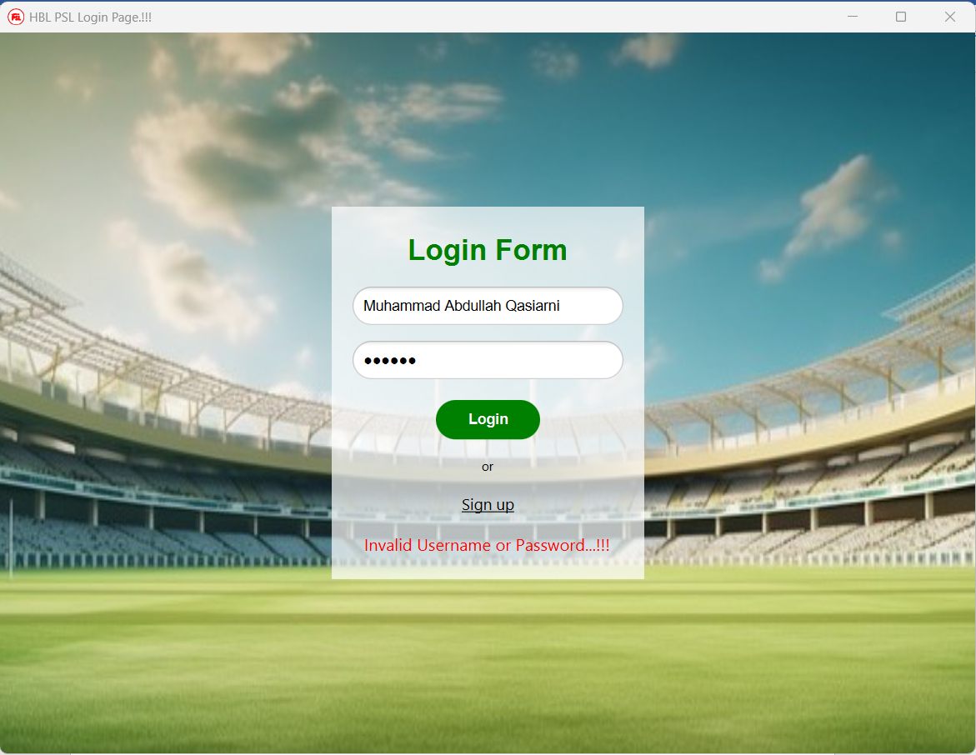

Click on sign up if you don't have account the sign of will require username password and confirm password. If there is already an account on specific username it will not proceed

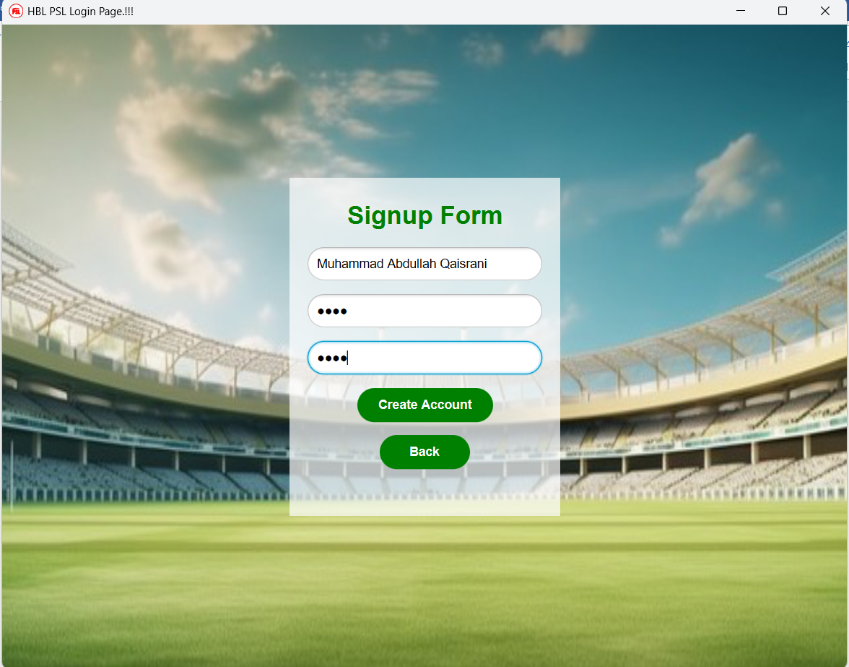

In the main menu there are three main options on the top which are teams matches schedule points table and there is a video of psl and there are two button assigned for it 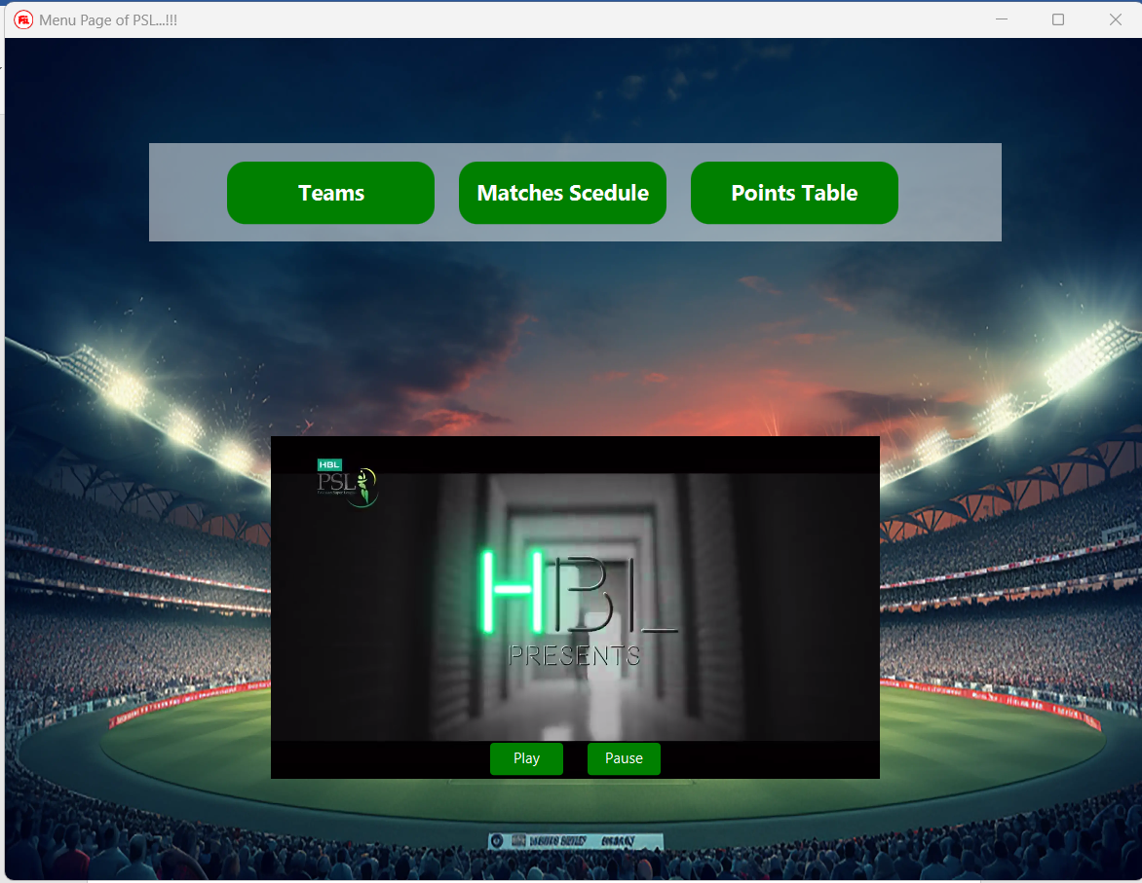play and pause buttons

When you click on teams a new window will appear with shows 3 buttons on top right corner one is back to main other is at team there is deleting and in the centre the already editing can be shown which team is a button. 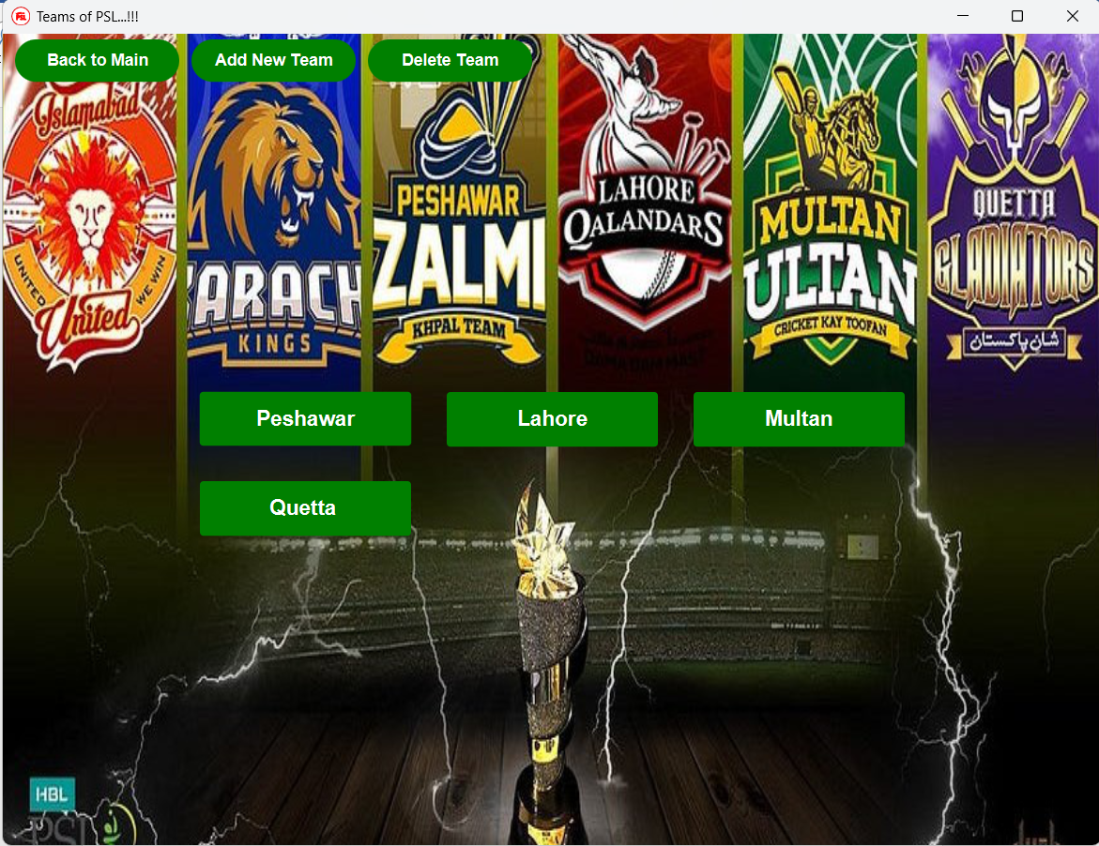

When you click on add new team a new window elevation l the team name, team captain head coach batting coach bowling coach team owner can be written and home city can be selected in the list which contain all the largest city of Pakistan to buttons are available on save other is back if you click on save it will say team same successfully in a pop up

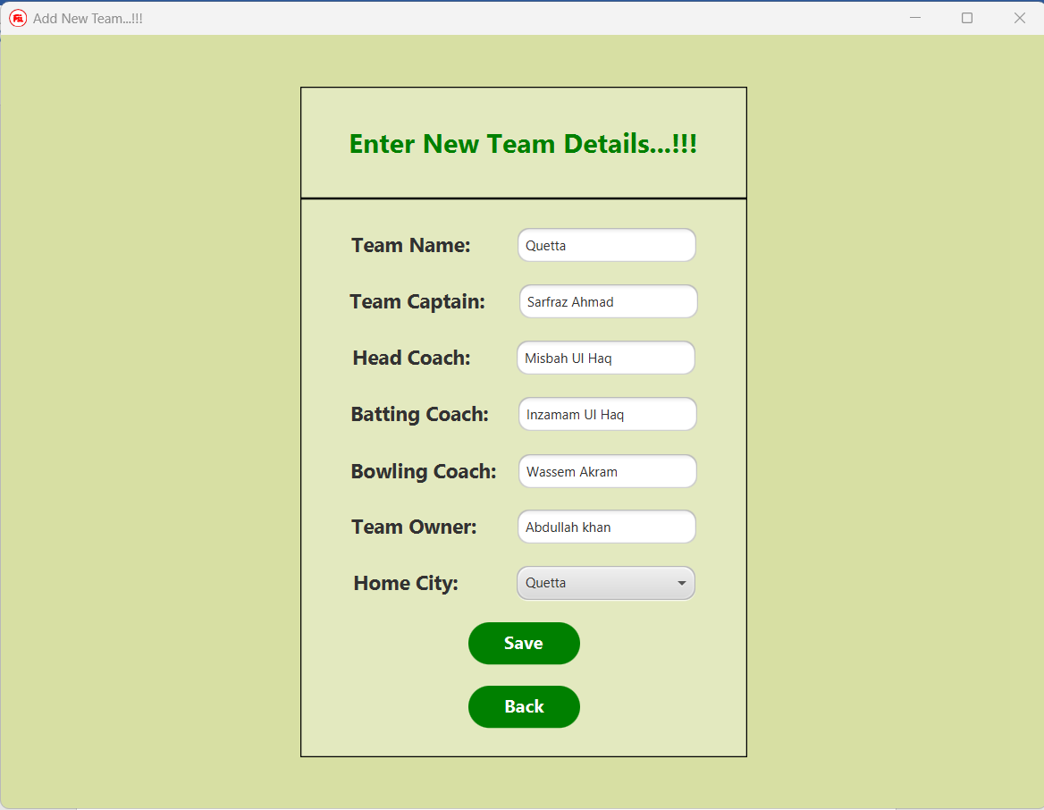

If you click on delete button a new window will appear and there is return enter the team name you want to delete just write the name and click the delete button if you don't want to delete just click back button

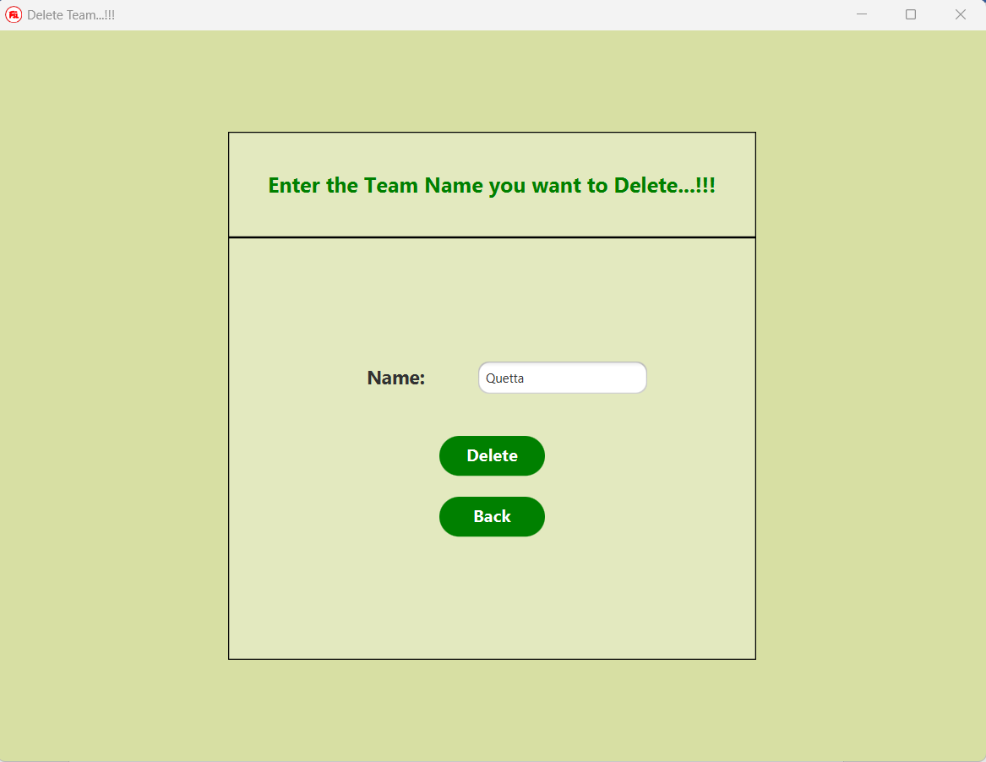

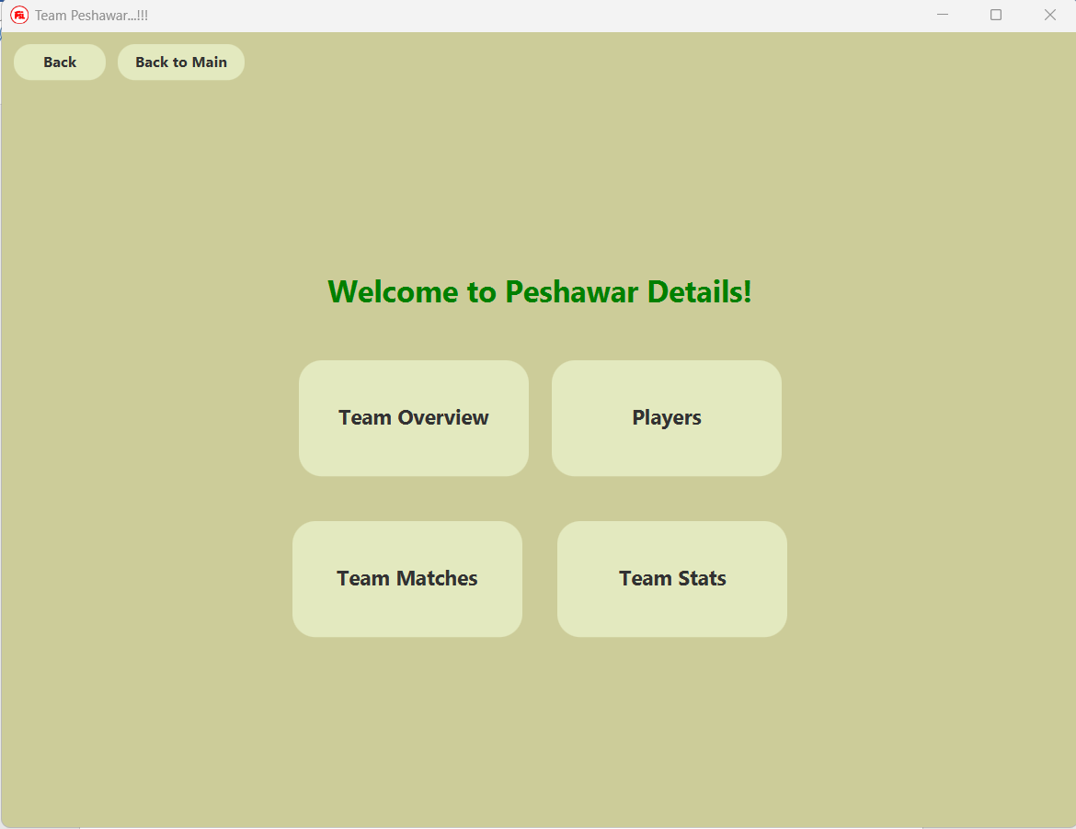 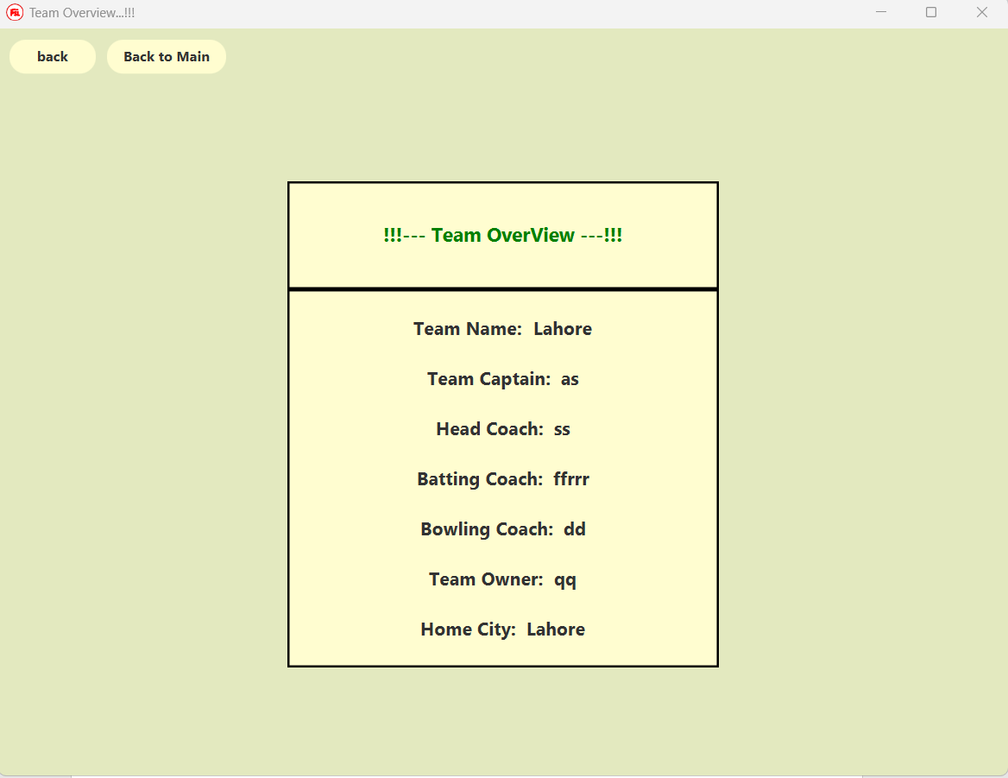 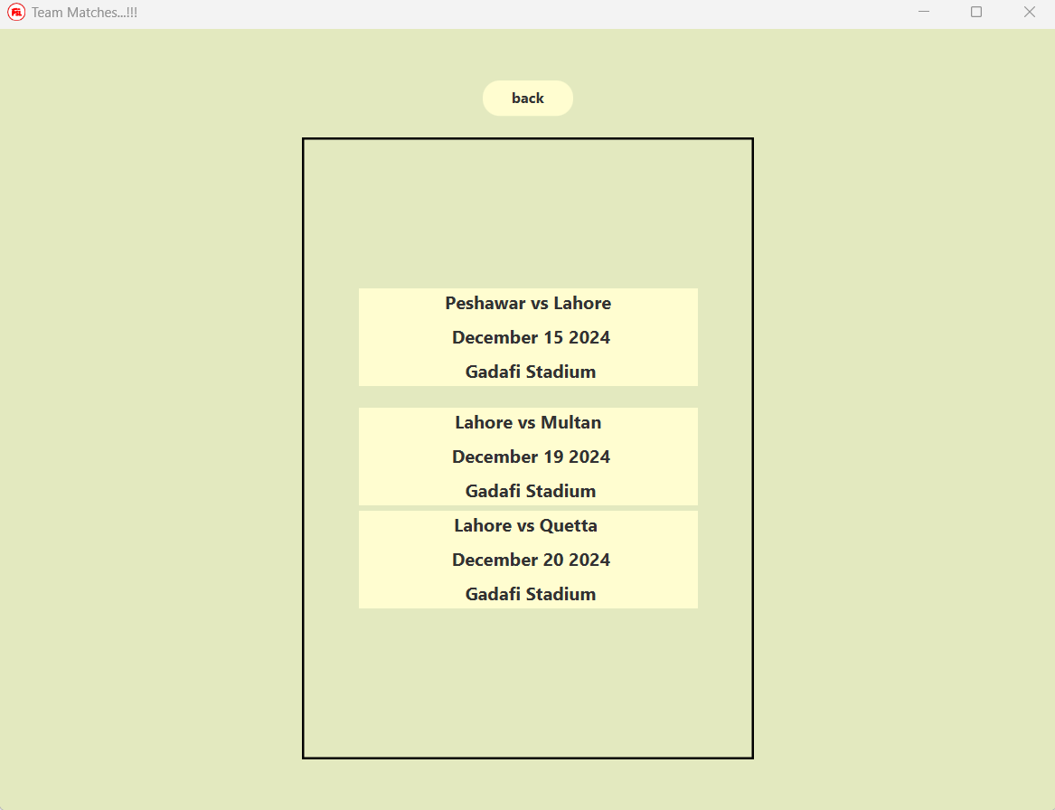

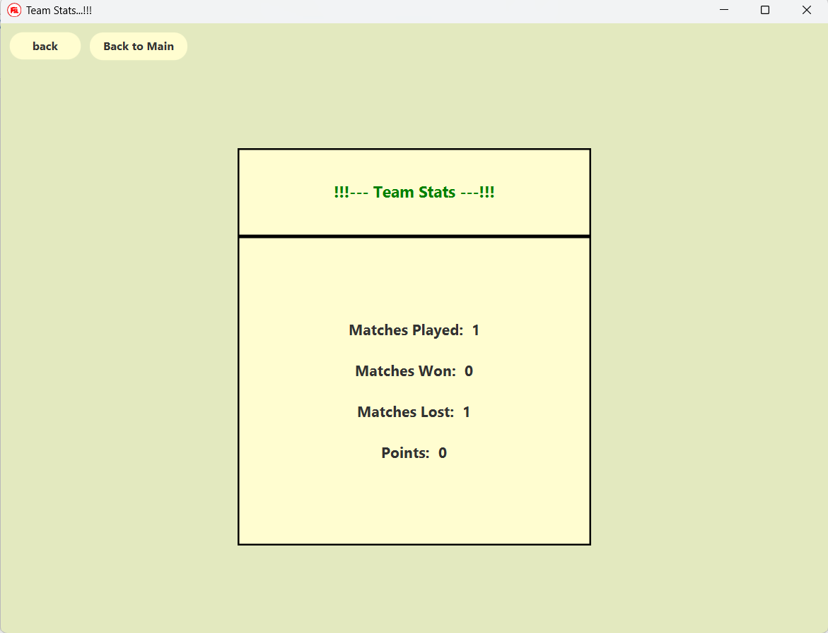

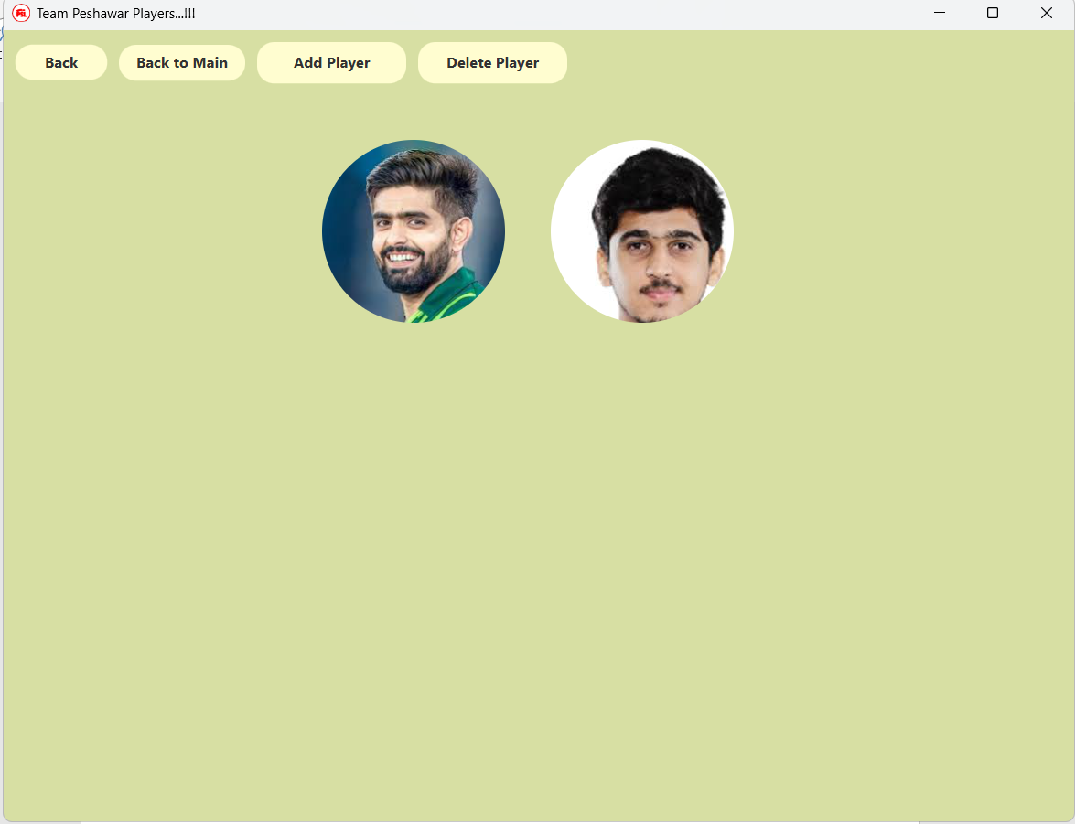

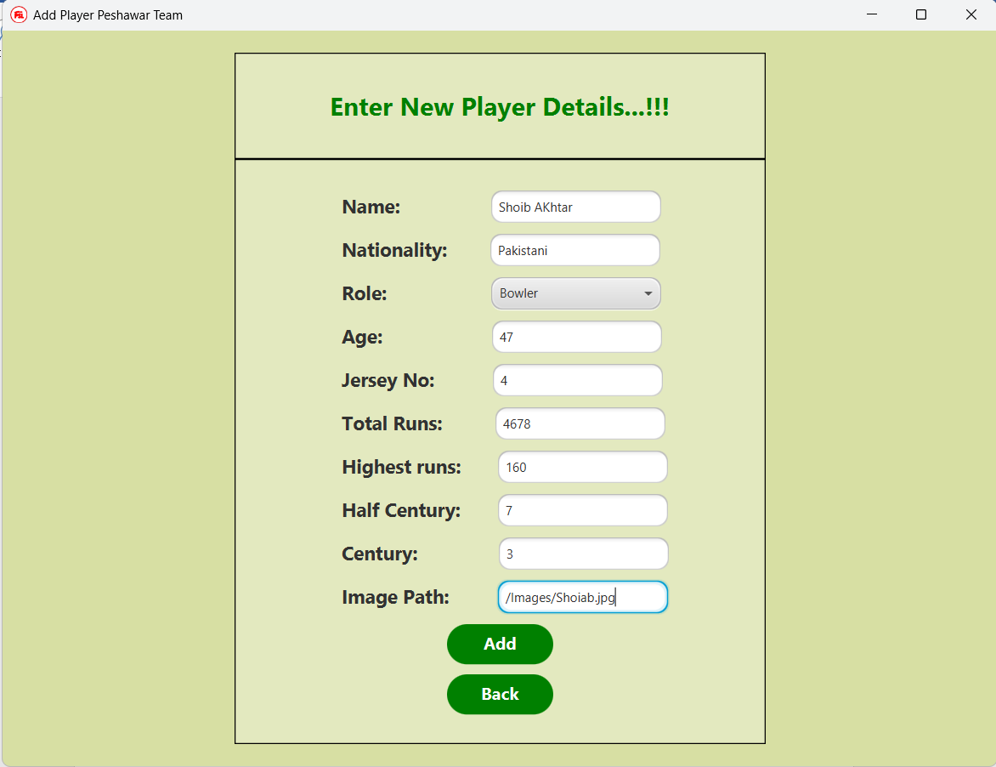

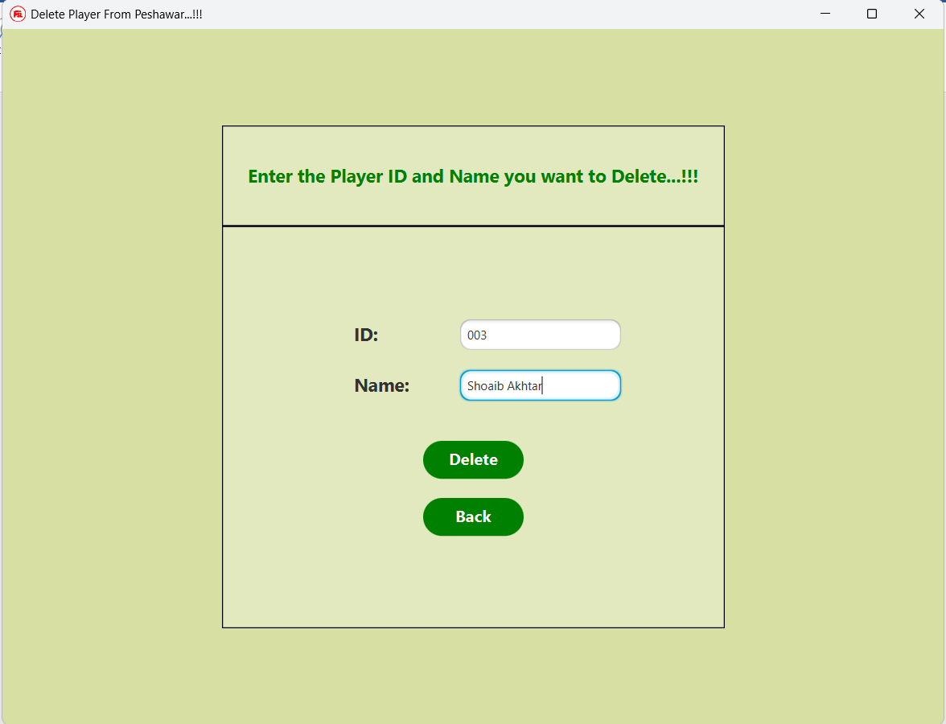

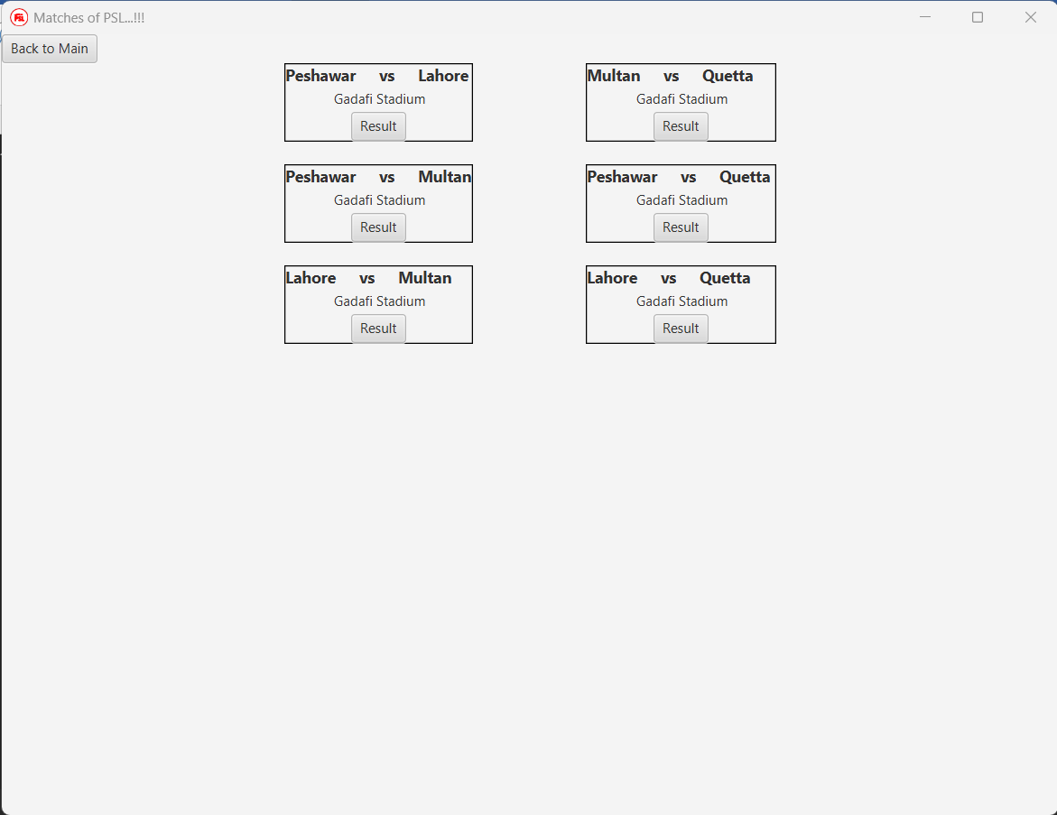If you click on Matches schedule this appear. This window has back to main button and result button is assigned to each match scheduled.

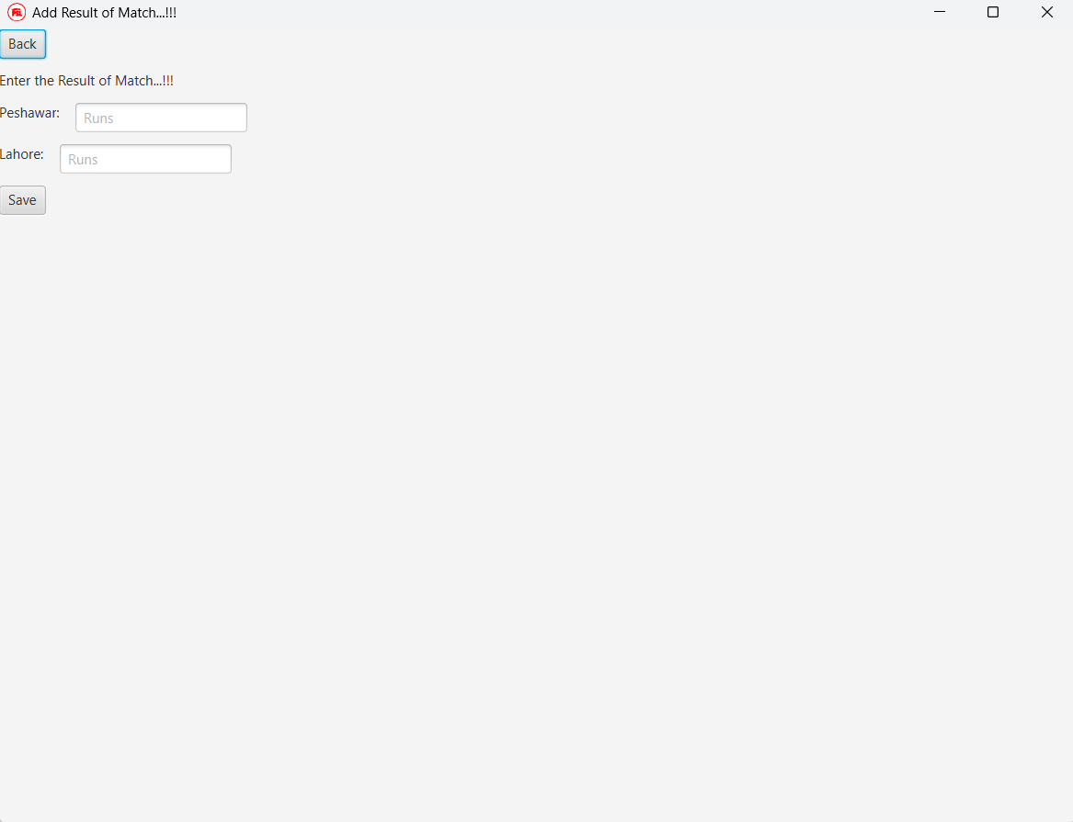

When you click on points table this table View appears. Note that this automatically updated when you enter the result in the scheduled matches. It also contain back to main button for going back.

